

**department of Computer Engineering & Applications**

**Institute of Engineering & Technology**

Lab Manual

**Name : Prajjwal Srivastava (43)**

**Subject Name & Code: MACHINE LEARNING LAB**

**Name: Himanshu Kushwaha (39)**

**Course: B. Tech. Section: B**

**Year: III Semester: V**

Linear regression

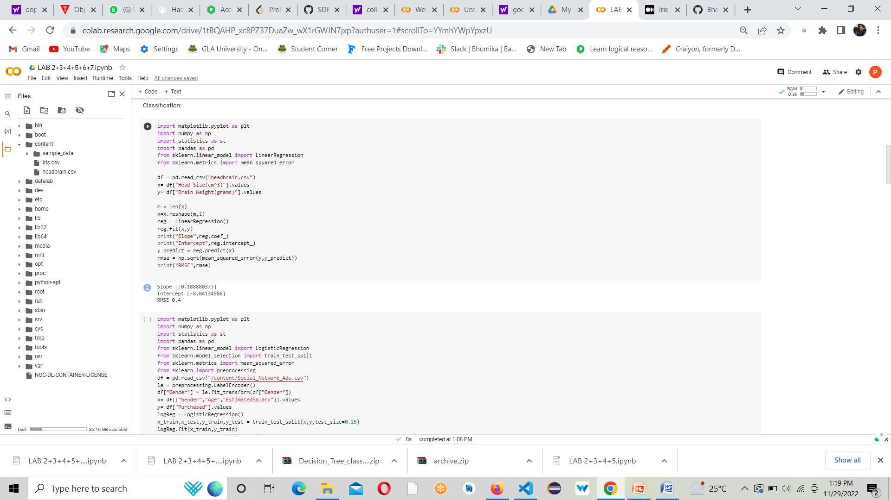

Logistic regression

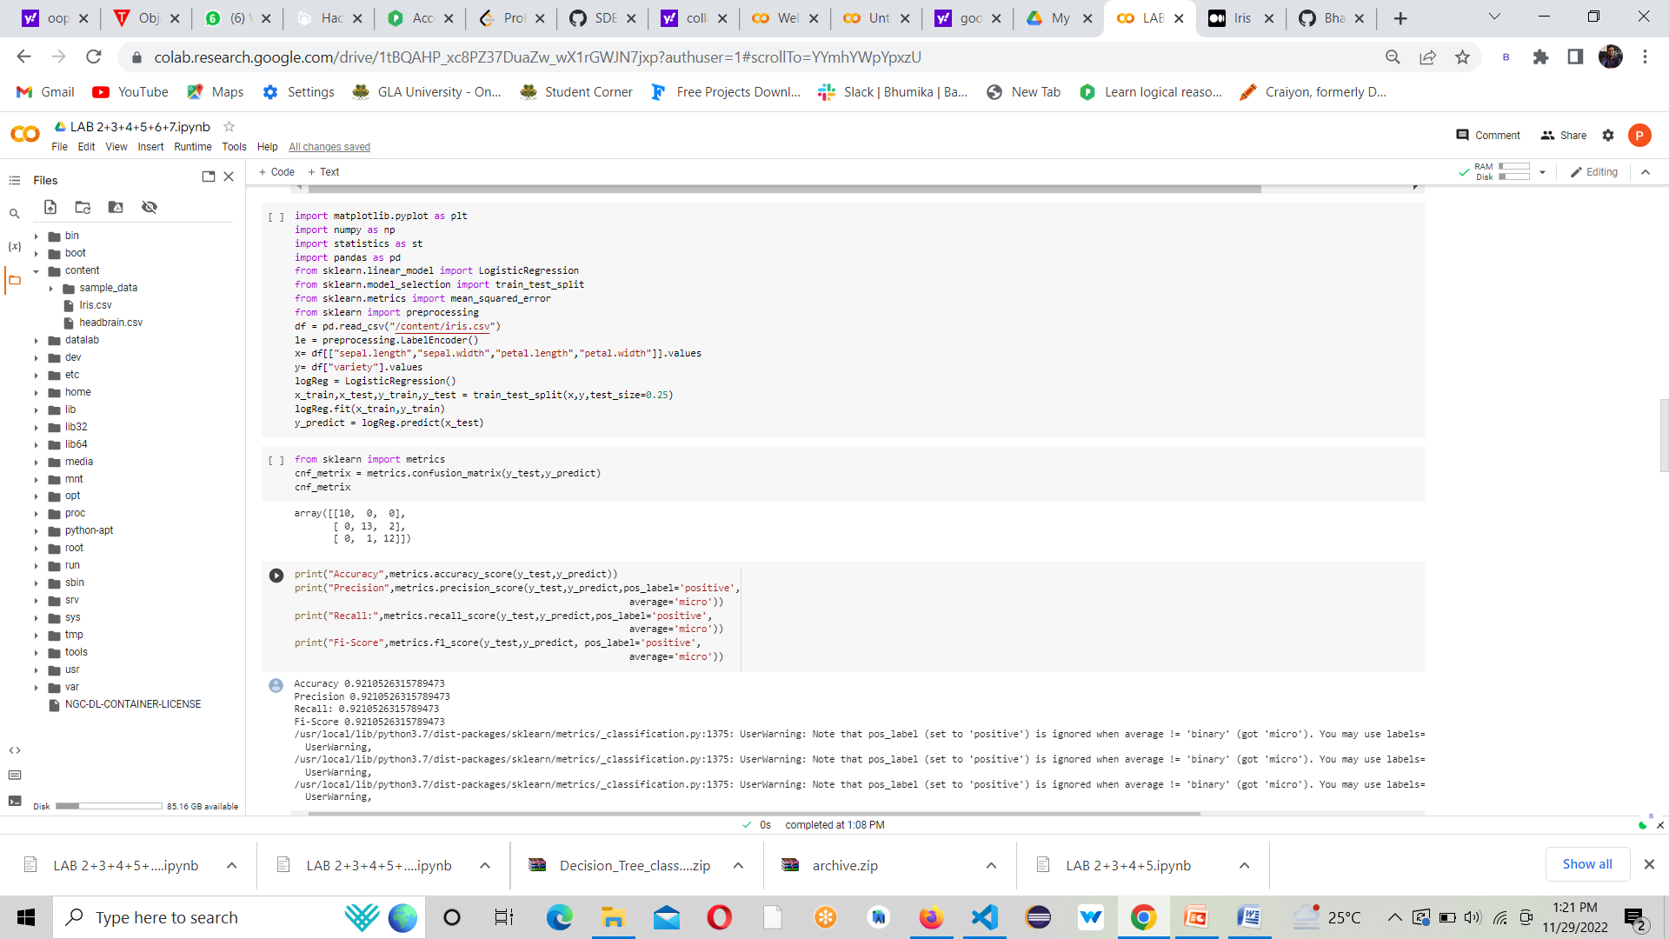

KNN ALGORITHM

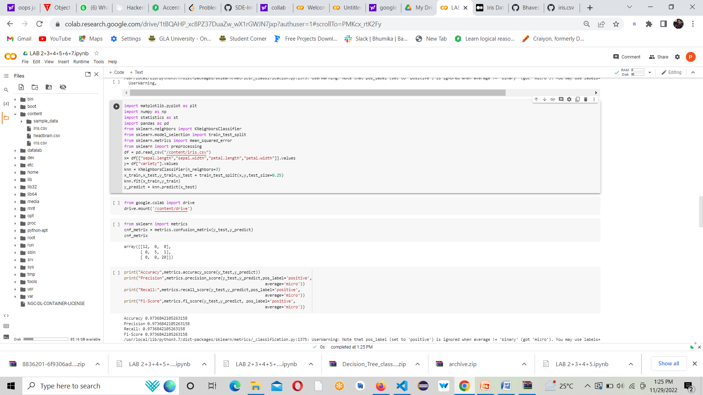

BAYES CLASSIFIER

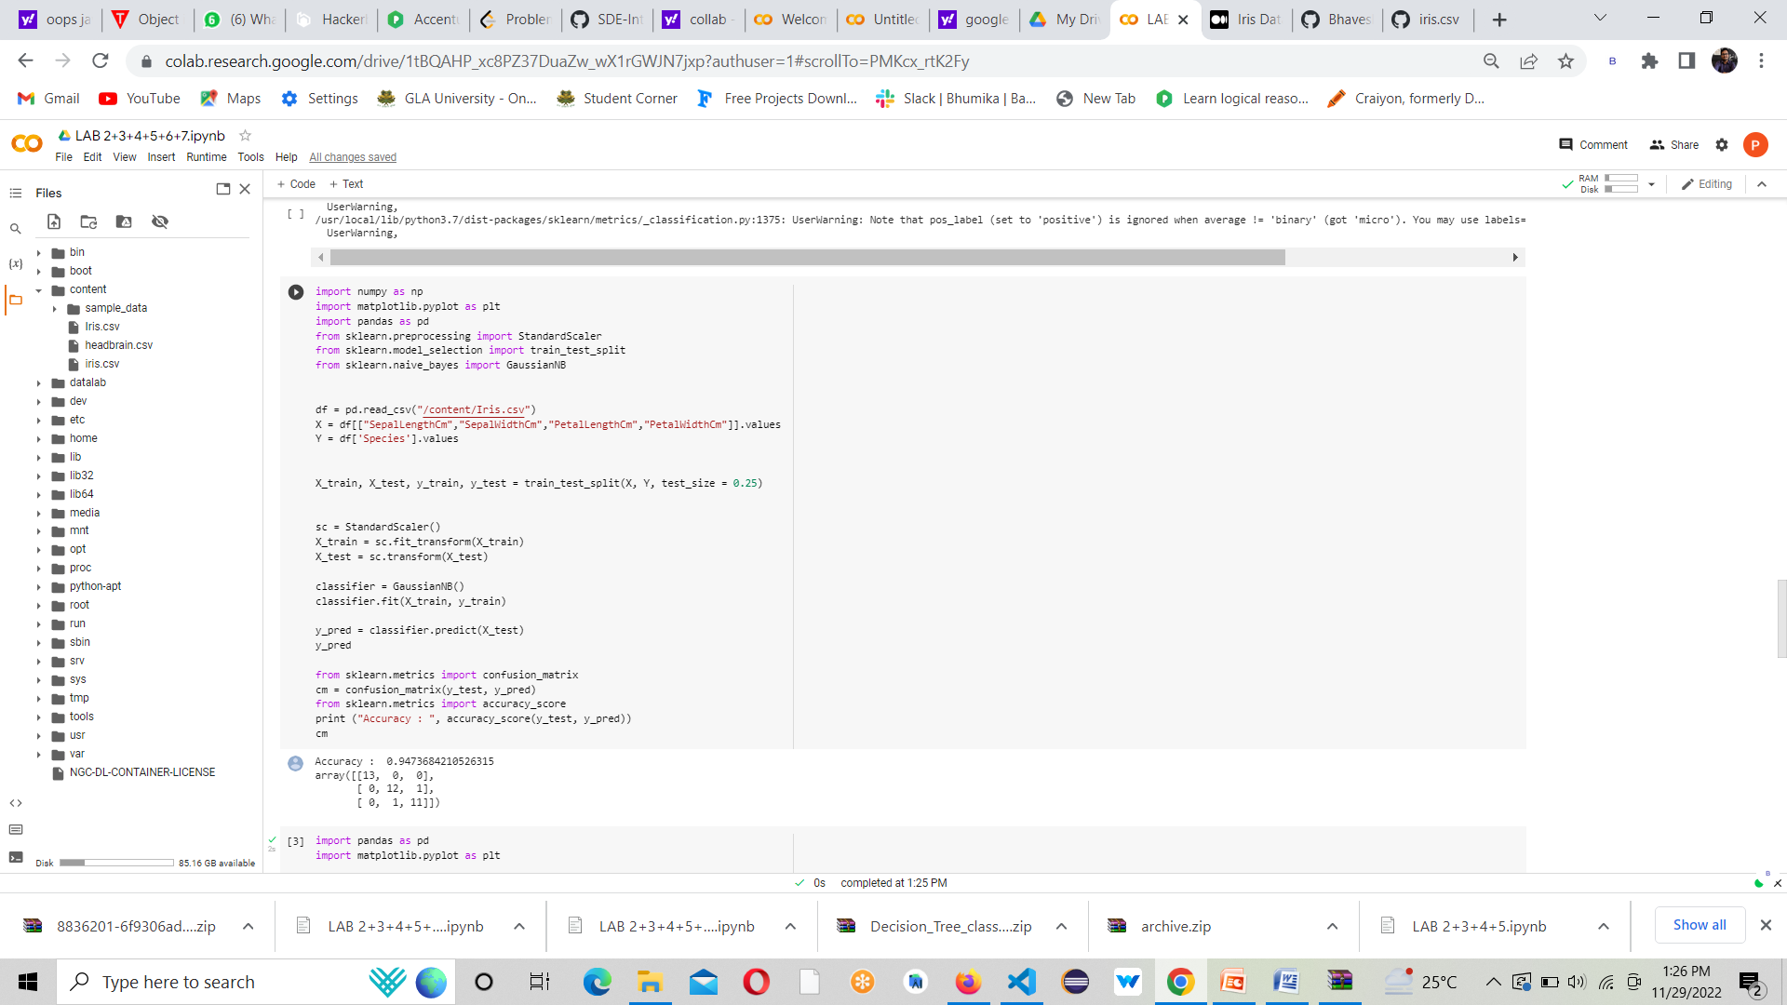

SVM

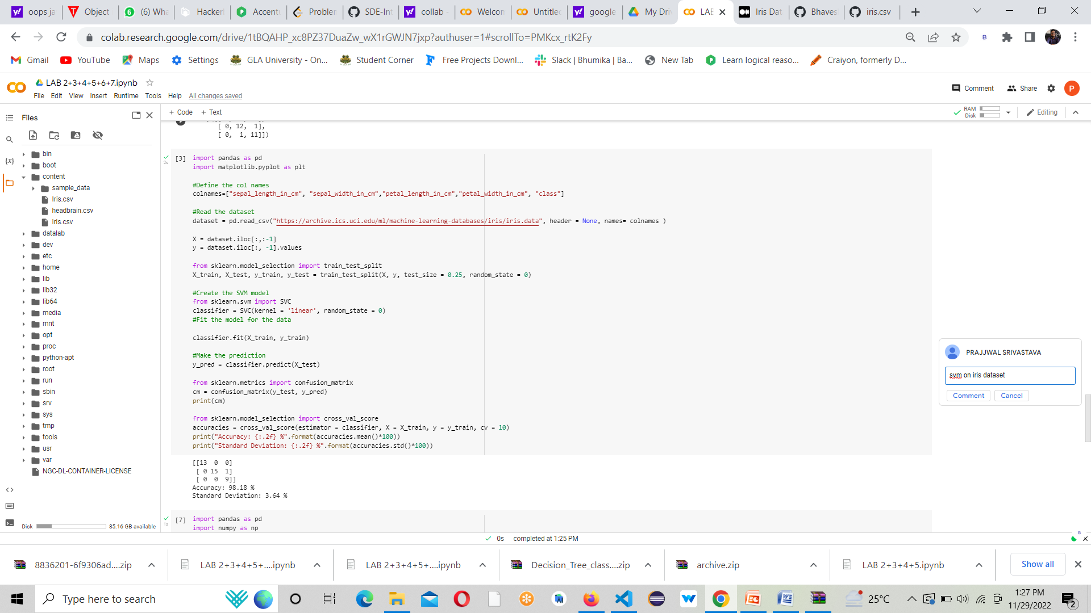

DECISION TREE

